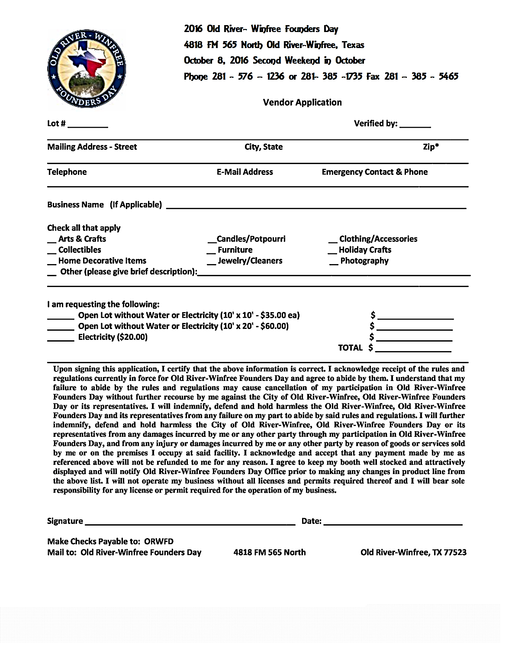

I am requesting the following: 10 x 10 w/o electricity is **FREE** ________

10 x 20 w/o electricity is **$10.00** _________

10 x 10 with electricity is **$20.00 __________**

10 x 20 with electricity is **$25.00** __________

Total __________

**2022 Old-River Winfree Founder’s Day**

**OCTOBER 8, 2022 10 AM TO 4 PM**

**4818 FM 565 North Old River-Winfree, Texas**

**October 22, 2022 Second Weekend in October**

**Phone : 281-385-1735 Fax: 281-385-5465**

