TALENT/PATRIOTIC SHOW
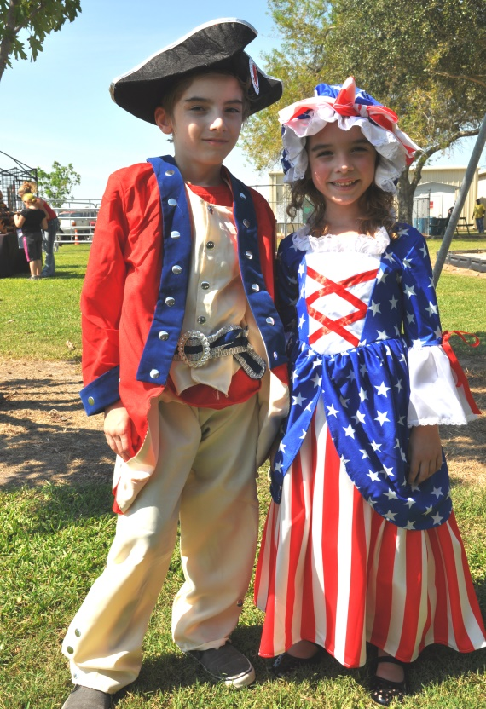
WHO: CHILDREN FROM NEWBORN TO TWELTH GRADE
WHEN: October 9, 2021 at 12 noon and again at 5:00 p.m.
(REGISTRATION STARTS AT 8:00 a.m.)
WHERE: OLD RIVER-WINFREE FOUNDERS DAY
AT 4818 FM N. 565
PRIZES FOR ALL PARTICIPANTS!!!

RULES: AnyONE can dress up in Red, White and Blue outfits, Patriotic dress for example, military dress, Uncle Sam, Betsy Ross, Settlers, Minute Men, or historical costume. They will model their outfits on stage and perform with a song, poem, dance, cite the Pledge of Allegiance, etc. (Let them be creative) Any type of TALENT IS WELCOMED!!
----------------------------------------------------------------------------------------------------------------------------
REGISTRATION INFORMATION
Registration fee is if you want to make a patriotic donation to the Fisher House of Houston

NAME: ____________________________________Age _____________

Talent:______________________________________________________

Music or prop needed?________________________________________

THEY DO NOT HAVE TO PERFORM IT THEY JUST WANT TO MODEL THEIR
PATRIOTIC COSTUME/OUTFIT

(Parent of Legal Guardian) _________________________________________________give my child permission to participate in the ORW Founders Day Children’s Patriotic Parade. I give my permission to use any pictures taken at this event to be used on social media to promote future Founders Days.

