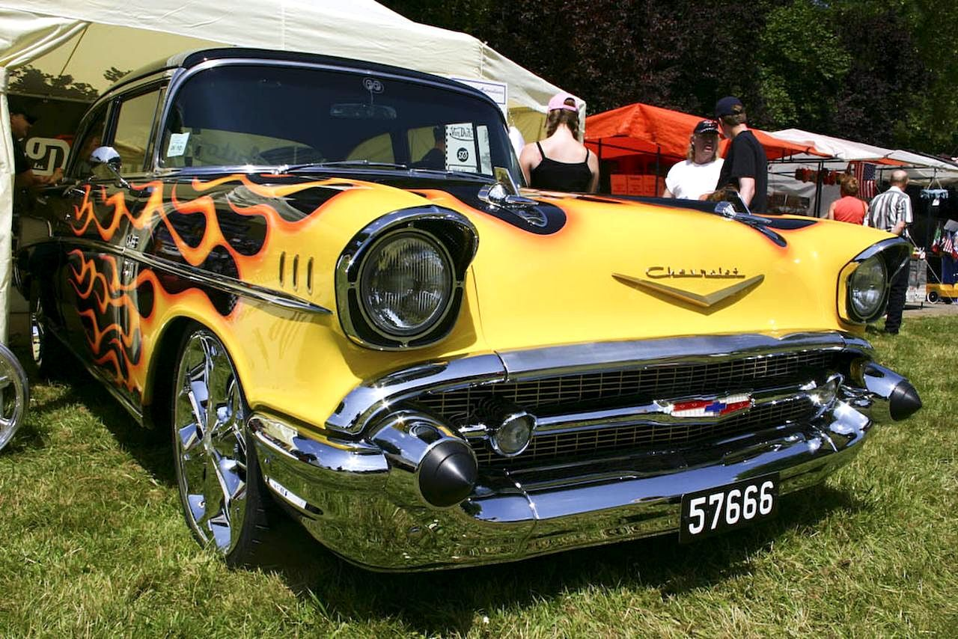

**$10.00 Registration** Fee Proceeds go to One Tribe Foundation and Chamber County Veterans Association

BENEFITTING **TWO VETERAN’S CHARITIES:**

**ONETRIBE FOUNDATION**

**CHAMBERS COUNTY VETERANS** **ASSOCIATION**

OLD RIVER WINFREE FOUNDERS DAY 2022

Oct. 8, 2022 From 10 am to 3pm pm

CAR and Truck SHOW

And Motorcycles Too

**1, 2, and 3 PRIZES AND People Choice Awards will be Given**

Entrants Name: ________________________________

Address: ________________________________

Email Address: ________________________________

Phone Number ________________________________

Vehicle Type: Car Truck Motorcycle

*(Circle One)*

Make ___________________ Model_______________ Year_______

Color ________________ Additional Info: _____________________________

Entry Number: ________________

Paid: Cash Check Credit Card

(*Circle One)*