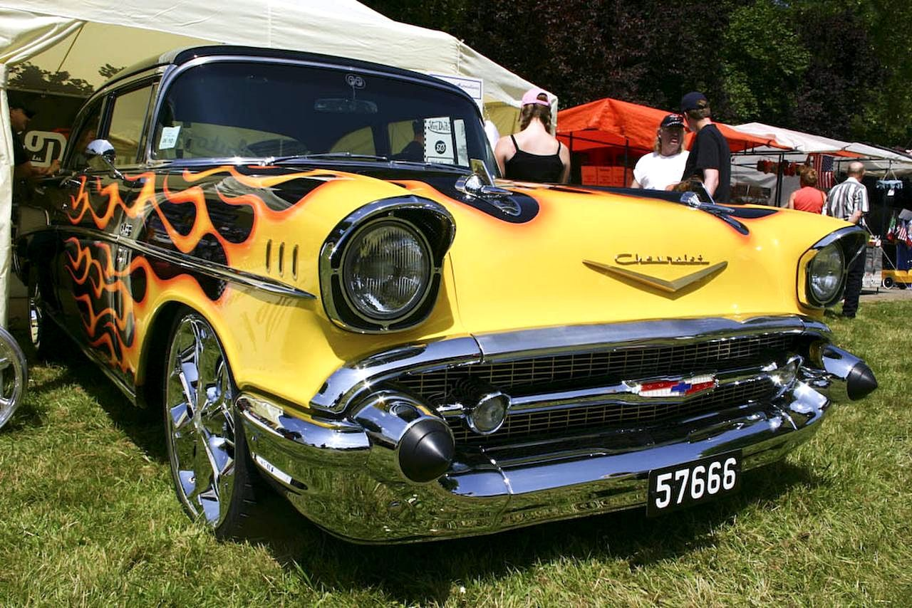

**TOP TEN PEOPLE’S CHOICE AWARD (top 10 will receive a trophy)**

Entrants Name: ________________________________

Address: ________________________________

Email Address: ________________________________

Phone Number ________________________________

Vehicle Type: Car Truck Motorcycle

*(Circle One)*

Make ___________________ Model_______________ Year_______

Color ________________ Additional Info: _____________________________

Entry Number: ________________

Paid: Cash Check Credit Card

(*Circle One)*

**$10.00 Registration** Fee Proceeds go to OneTribe and Chamber County Veterans Assistance

OLD RIVER WINFREE FOUNDERS DAY 2021

Oct. 9, 2021 9 am to 3 pm

CAR and Truck SHOW

And Motorcycles Too

BENEFITTING **TWO VETERAN’S CHARITIES**

**ONETRIBE AND**

**CHAMBERS COUNTY VETERANS** ASSITANCE