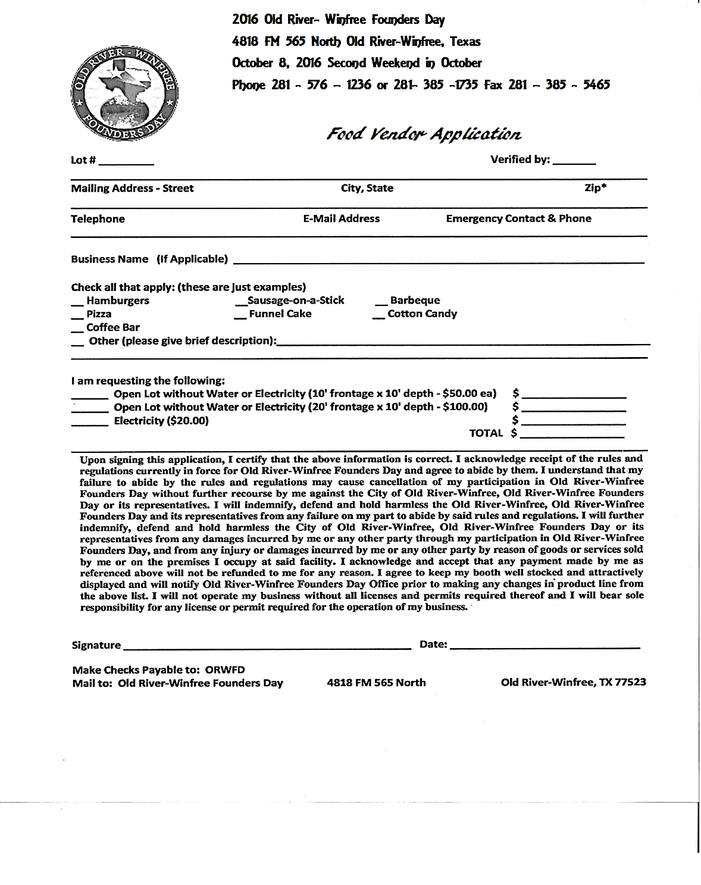

We will require a donation for the Live and Silent Auction- Call Linda

10 X 10……….Free 10 x 20 with electricity ……….$ 35.00 

10 X 20 ………$20.00  10 x 10 with electricity…….$20.00 

Total…………….

10 x 10 with electricity…….$20.00

**2021 Old-River Winfree Founder’s Day Festival**

**4818 FM 565 North Old River-Winfree, Texas**

**October 9, 2021 9 am to 6 pm**

**Phone : 281-385-1735 Cell: 832-993-4896**